ANNUAL REPORT
2018

MISSION / ACKNOWLEDGEMENTS
Rockland County’s Percent for Art program was established through Local Law #6 of 1986 introduced by legislators Harriet Cornell and Bruce Levine. Under guidelines approved by the County Legislature on March 7, 2006, its mission is “to enhance the quality of life in Rockland County through Public Art.” Now in its 32st year AIPP has installed more than 50 artworks at accessible county sites. It has also restored valuable county public artworks, as well as a collection of WPA paintings entrusted to the county, in perpetuity, by the Federal government.

AIPP functions under the guidance of the AIPP committee. Members include: Co-chairs Erin Martin (Monsey) and Ken Linsner (Sloatsburg), Shari Fischberg (Upper Nyack), Emily Harvey (Garnerville), Pat Hickman (Haverstraw), Carl Opalek (New City), Judy Esterow (Suffern), Dan White (Nyack), and Dan Sherman (Sparkill). Frances Wells (Piermont) left the committee this year after exemplary service, and Lisa D’Amico (Bardonia) joined the committee in January 2018.

Represented areas of their expertise include: fine arts, photography, graphic design, art history, art education, curatorial, art appraisal, conservation, restoration, landscape architecture, technology, social media, art publishing, illustration and arts marketing.

The committee works cooperatively with Rockland’s County Executive,
Ed Day, who has supported new projects throughout the year.

AIPP functions under Rockland County’s Department of General Services lead by Robert H. Gruffi, Director of Facilities Management. Bob provides AIPP with technical advice and installation support for its projects and helps AIPP work efficiently with the various branches of county government including the County Legislature, the Department of Budget and Management, the Department of Law, the Parks Department, the Highway Department and the Drainage Department.

Rockland Center for the Arts administers all aspects of the AIPP program.

2018 COMPLETED PROJECTS

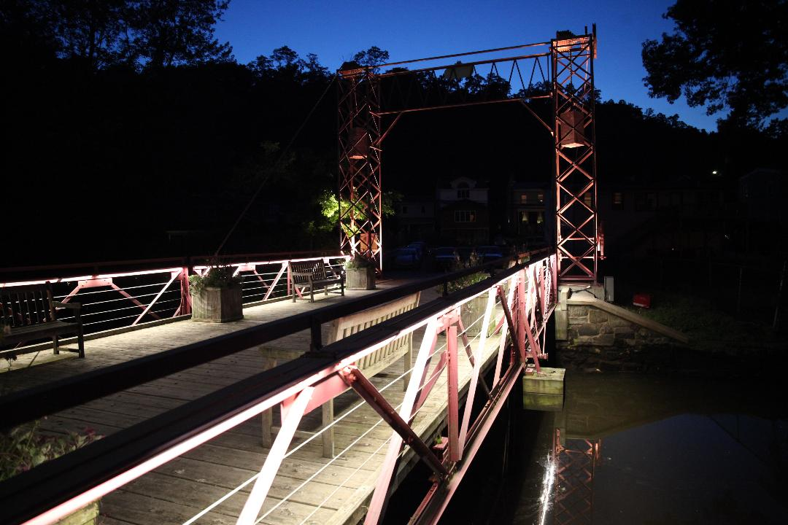

Bridge Street Drawbridge Illumination
Piermont, New York

The lighting design firm of Kugler Ning designed a permanent, solar-powered LED light installation to provide illumination and enhancement of this historic and beloved bridge. The public dedication and first lighting took place on October 5, 2018 and was attended by over 200 people. The evening included a performance by local resident Tom Chapin and the Chapin Family Singers. Speakers included County Executive Ed Day, Orangetown Supervisor Christopher Day, Piermont Mayor Bruce Tucker and Piermont Historian Richard Esnard. The project was, in part, privately underwritten by the Village of Piermont and a memorial sponsor.
Landscape Architect, Dan Sherman, chaired the AIPP project committee and secured a $14,000 grant for the solar power installation from the Green Mountain Sun Club Foundation.
Frances Wells arranged the entertainment and Shari Fischberg served on the committee.

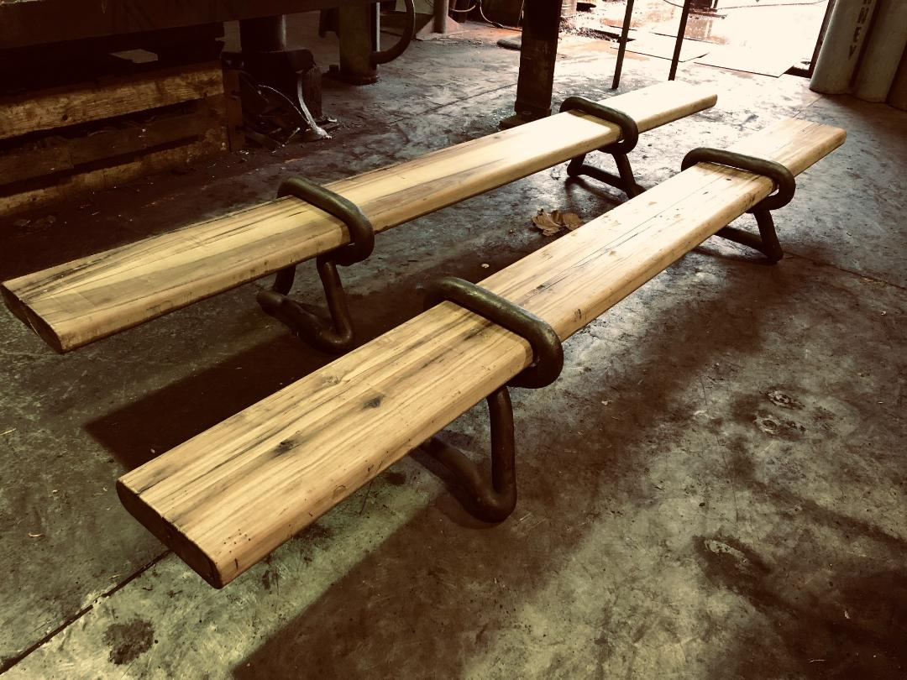

Bridge Street Drawbridge
Two Lariat Plank Benches
Piermont, New York

Sculptor and ironmonger, James
Garvey of Piermont, designed and fabricated two hand-forged iron and
wood plank benches for the Bridge Street Drawbridge to accommodate visitors and residents. The benches were dedicated on October 5th along with the drawbridge light installation. Dan Sherman chaired this project.

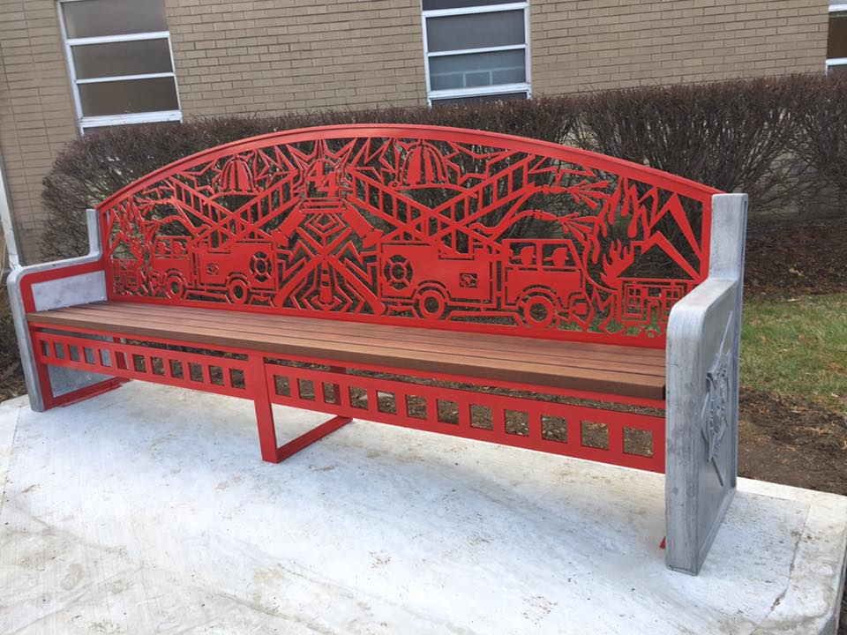

Fire Training Center
Two Art Benches
Pomona, New York

Sculptor Eric David Laxman of Upper Nyack was selected for his aluminum, wood and concrete bench design featuring a laser-cut firehouse motif and hand-cast concrete FTC medallions. Two (2) identical benches provide decorative and functional seating for the front of the FTC building. The project was completed and installed on December 11, 2018. The subcommittee includes Erin Martin (Chair), Emily Harvey, Pat Hickman and Dan Sherman.

2018 PROJECTS IN PROCESS

Demarest Kill Park Sculptures
New City, New York

Sculptor Tom Holmes’ design for a multi-part, interactive installation was selected for the grassy area at the front of the park adjacent to New Hempstead Road. A large, red-colored sculpture will be the focal point with additional elements of. three light-towers, two bluestone benches and a stone chess table. The subcommittee for this project is Pat Hickman, (Chair); Dan White, Frances Wells and Erin Martin.

CONSERVATION OF EXISTING PUBLIC ARTWORK

Over the years, public artwork can
deteriorate and require restoration.
Maintaining county-owned public artwork respects the integrity of the artwork, preserves the intent of the artist, honors the viewing public, and preserves the value of objects that are a part of the county’s asset base.

CONSERVATION COMMITTEE REVIEW AND REPORTING
Members of AIPP’s conservation subcommittee, led by appraiser and conservator, Ken Linsner, conduct semi-annual reviews of existing AIPP-commissioned artworks and issue condition reports with recommendations for any conservation work needed. AIPP arranges for the restorations or repairs using project funds held back for maintenance needs on the original project. Dan White and Emily Harvey worked on this subcommittee in 2018.

CONNECTING TO THE PUBLIC:
AIPP ONLINE AND AIPP SOCIAL MEDIA

AIPP Website
www.aipprockland.org
AIPP’s website posts calls for entry for upcoming projects, features an archive of completed projects with photos and descriptions, and a clickable site map with directions. A video featuring many projects and the history of the program is posted online for public viewing.

Social Media
AIPP committee member, Lisa D’Amico, designed and administers AIPP Facebook and Instagram pages that feature new up-to-date news and studio-based video interviews with AIPP commissioned artists.

AIPP PUBLIC ANNOUNCEMENTS THROUGH ROCA

www.rocklandartcenter.org
New projects, committee vacancies, public notices of dedications and new installations are also posted through RoCA’s email notification system. RFQ replies are processed at RoCA into a format viewable for selection by the AIPP Committee members.

2018 AIPP ORGANIZATIONAL AND EDUCATIONAL ACTIVITIES

AIPP PR and PHOTO ARCHIVE
The AIPP Committee maintains an archive of video, photos and press coverage of AIPP installations and artworks. Committee member Judy Esterow chairs the PR standing committee, prepares press releases on completed projects and coordinates dedication ceremonies and their associated print and electronic news media releases.

A COMMUNITY OF ARTISTS
Since the mid-19th Century, Rockland County has attracted world class artists who chose to make their home in this beautiful region in the lower Hudson Valley. With such a rich cultural past and present, it is fitting that Rockland became the first County in New York State outside New York City to pass a Percent for Art Law that marks its place among those enlightened communities and states that support and display works of publicly accessible art. Today, through AIPP, Rockland residents can find significant artwork throughout their county.

To date, 80% of commissions have been awarded to Rockland County artists, Other projects have brought to the county the work of accomplished artists from beyond our borders. This open exchange of creativity encourages our own artists, who, in turn, seek public art commissions elsewhere. In addition, these projects provide opportunities for local vendors to perform ancillary work, beautify the environment in which we live and work, attract the attention of visitors, enhance the reputation of the county and tie the community to both the national and international art world.
Report prepared by
Julianne Ramos, AIPP Administrator January 9, 2018

Photos by:
Dan Sherman. (Lariat Plank Benches)
Eric David Laxman. (FTC Benches)
Betsey Franco Feeney (Drawbridge)

Logo:
AIPP logo designed by Carl Opalek.

